
San Francisco Bay University

CE450 Fundamentals of Embedded Engineering
Lab 9 LCD Display

Objectives:
In this week, students will design the program to display the characters and strings through GPIO ports on Raspberry Pi bord and do hands-on exercise through lab assignments.

Introduction:
We will learn how to use LCD1602 to display characters and strings as exercises in the lab section.

Equipment:
The equipment you require is as follows:
- Laptop & Raspberry Pi 3 model Board
- SunFounder Super Starter Kit V2.0 for Raspberry Pi
- LCD1602 display

The Laboratory Procedure:
- Hardware connection
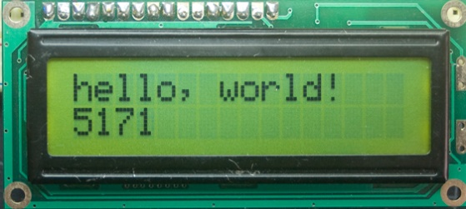
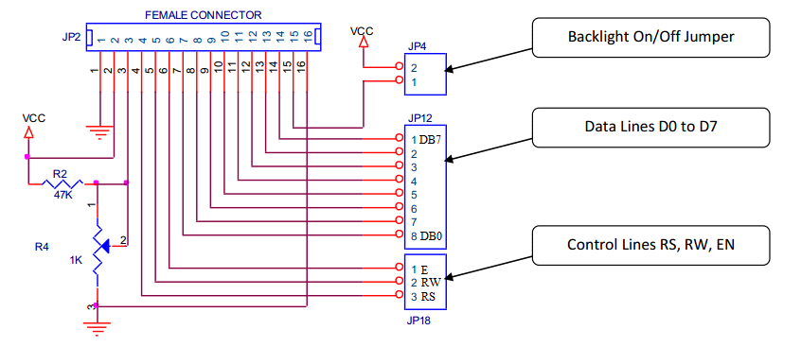11
P15-P16: Backlight
P3: LCD Contrast Adjustment

DB0-DB7: Data & Command inputs
RS--- Instruction/Date Selection
E--- Enable
R/W=0 Always in Write Mode
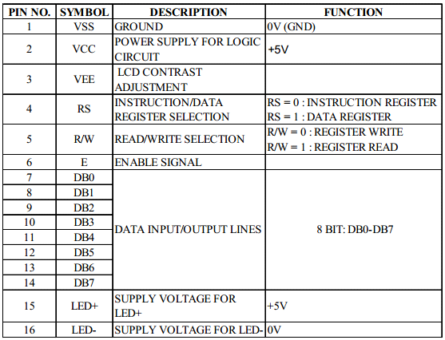

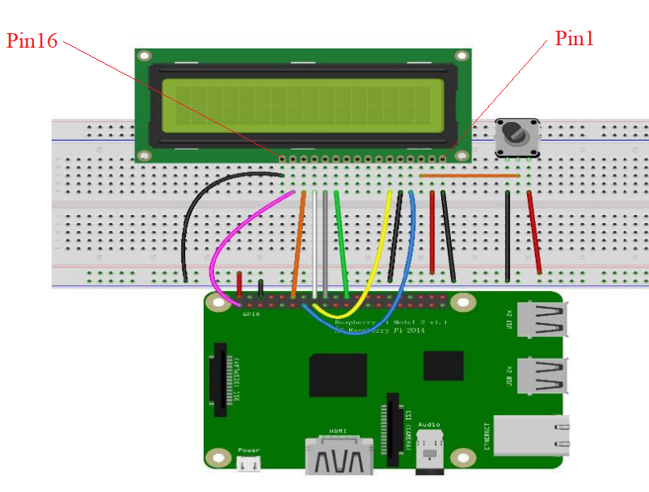
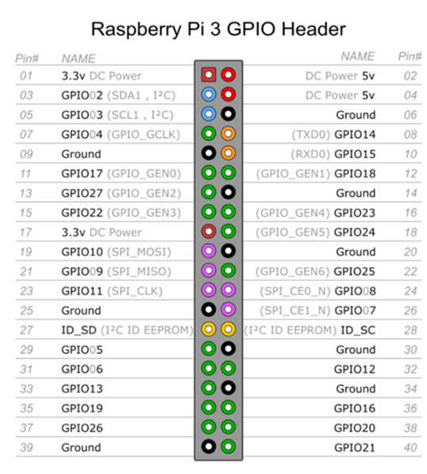

- Control program in Python

# Python Program

from time import sleep

class LCD:
# commands
LCD_CLEARDISPLAY = 0x01 # 0000_0001
LCD_RETURNHOME = 0x02
LCD_ENTRYMODESET = 0x04
LCD_DISPLAYCONTROL = 0x08
LCD_CURSORSHIFT = 0x10
LCD_FUNCTIONSET = 0x20
LCD_SETCGRAMADDR = 0x40
LCD_SETDDRAMADDR = 0x80

# flags for display entry mode
LCD_ENTRYRIGHT = 0x00
LCD_ENTRYLEFT = 0x02
LCD_ENTRYSHIFTINCREMENT = 0x01
LCD_ENTRYSHIFTDECREMENT = 0x00

# flags for display on/off control
LCD_DISPLAYON = 0x04
LCD_DISPLAYOFF = 0x00
LCD_CURSORON = 0x02
LCD_CURSOROFF = 0x00
LCD_BLINKON = 0x01
LCD_BLINKOFF = 0x00

# flags for display/cursor shift
LCD_DISPLAYMOVE = 0x08
LCD_CURSORMOVE = 0x00

# flags for display/cursor shift
LCD_DISPLAYMOVE = 0x08
LCD_CURSORMOVE = 0x00
LCD_MOVERIGHT = 0x04
LCD_MOVELEFT = 0x00

# flags for function set
LCD_8BITMODE = 0x10
LCD_4BITMODE = 0x00
LCD_2LINE = 0x08
LCD_1LINE = 0x00
LCD_5x10DOTS = 0x04
LCD_5x8DOTS = 0x00

def __init__(self, pin_rs=27, pin_e=22, pins_db=[25, 24, 23, 18], GPIO = None):
# Emulate the old behavior of using RPi.GPIO if we haven't been given
# an explicit GPIO interface to use if not GPIO:
import RPi.GPIO as GPIO
self.GPIO = GPIO
self.pin_rs = pin_rs
self.pin_e = pin_e
self.pins_db = pins_db

self.used_gpio = self.pins_db[:]
self.used_gpio.append(pin_e)
self.used_gpio.append(pin_rs)

self.GPIO.setwarnings(False)
self.GPIO.setmode(GPIO.BCM)
self.GPIO.setup(self.pin_e, GPIO.OUT)
self.GPIO.setup(self.pin_rs, GPIO.OUT)

for pin in self.pins_db:
self.GPIO.setup(pin, GPIO.OUT)

self.write4bits(0x33) # initialization
self.write4bits(0x32) # initialization
self.write4bits(0x28) # 2 line 5x7 matrix
self.write4bits(0x0C) # turn cursor off 0x0E to enable cursor
self.write4bits(0x06) # shift cursor right

self.displaycontrol = self.LCD_DISPLAYON | self.LCD_CURSOROFF | self.LCD_BLINKOFF

self.displayfunction = self.LCD_4BITMODE | self.LCD_1LINE | self.LCD_5x8DOTS
self.displayfunction |= self.LCD_2LINE

""" Initialize to default text direction (for romance languages) """
self.displaymode = self.LCD_ENTRYLEFT | self.LCD_ENTRYSHIFTDECREMENT
self.write4bits(self.LCD_ENTRYMODESET | self.displaymode)
# set the entry mode

self.clear()

def begin(self, cols, lines):
if (lines > 1):
self.numlines = lines
self.displayfunction |= self.LCD_2LINE
self.currline = 0

def home(self):
self.write4bits(self.LCD_RETURNHOME) # set cursor position to zero
self.delayMicroseconds(3000) # this command takes a long time!

def clear(self):
self.write4bits(self.LCD_CLEARDISPLAY) # command to clear display
self.delayMicroseconds(3000)
# 3000 microsecond sleep, clearing the display takes a long time

def setCursor(self, col, row):
self.row_offsets = [ 0x00, 0x40, 0x14, 0x54 ]

if ( row > self.numlines ):
row = self.numlines - 1 # we count rows starting w/0

self.write4bits(self.LCD_SETDDRAMADDR | (col + self.row_offsets[row]))

def noDisplay(self):
# Turn the display off (quickly)
self.displaycontrol &= ~self.LCD_DISPLAYON
self.write4bits(self.LCD_DISPLAYCONTROL | self.displaycontrol)

def display(self):
# Turn the display on (quickly)
self.displaycontrol |= self.LCD_DISPLAYON
self.write4bits(self.LCD_DISPLAYCONTROL | self.displaycontrol)

def noCursor(self):
# Turns the underline cursor on/off
self.displaycontrol &= ~self.LCD_CURSORON
self.write4bits(self.LCD_DISPLAYCONTROL | self.displaycontrol)

def cursor(self):
# Cursor On
self.displaycontrol |= self.LCD_CURSORON
self.write4bits(self.LCD_DISPLAYCONTROL | self.displaycontrol)

def noBlink(self):
# Turn on and off the blinking cursor
self.displaycontrol &= ~self.LCD_BLINKON
self.write4bits(self.LCD_DISPLAYCONTROL | self.displaycontrol)

def noBlink(self):
# Turn on and off the blinking cursor
self.displaycontrol &= ~self.LCD_BLINKON
self.write4bits(self.LCD_DISPLAYCONTROL | self.displaycontrol)

def DisplayLeft(self):
# These commands scroll the display without changing the RAM
self.write4bits(self.LCD_CURSORSHIFT | self.LCD_DISPLAYMOVE | self.LCD_MOVELEFT)

def scrollDisplayRight(self):
# These commands scroll the display without changing the RAM
self.write4bits(self.LCD_CURSORSHIFT | self.LCD_DISPLAYMOVE | self.LCD_MOVERIGHT);

def leftToRight(self):
# This is for text that flows Left to Right
self.displaymode |= self.LCD_ENTRYLEFT
self.write4bits(self.LCD_ENTRYMODESET | self.displaymode);

def rightToLeft(self):
# This is for text that flows Right to Left
self.displaymode &= ~self.LCD_ENTRYLEFT
self.write4bits(self.LCD_ENTRYMODESET | self.displaymode)

def autoscroll(self):
# This will 'right justify' text from the cursor
self.displaymode |= self.LCD_ENTRYSHIFTINCREMENT
self.write4bits(self.LCD_ENTRYMODESET | self.displaymode)

def noAutoscroll(self):
# This will 'left justify' text from the cursor
self.displaymode &= ~self.LCD_ENTRYSHIFTINCREMENT
self.write4bits(self.LCD_ENTRYMODESET | self.displaymode)

def write4bits(self, bits, char_mode=False): # one of functions in class LCD
# Send command to LCD
self.delayMicroseconds(1000) # 1000 microsecond sleep
bits=bin(bits)[2:].zfill(8)
self.GPIO.output(self.pin_rs, char_mode)
for pin in self.pins_db:
self.GPIO.output(pin, False)
for i in range(4):
if bits[i] == "1":
self.GPIO.output(self.pins_db[::-1][i], True)
self.pulseEnable()
for pin in self.pins_db:
self.GPIO.output(pin, False)
for i in range(4,8):
if bits[i] == "1":
self.GPIO.output(self.pins_db[::-1][i-4], True)
self.pulseEnable()

def delayMicroseconds(self, microseconds):
seconds = microseconds / float(1000000)
# divide microseconds by 1 million for seconds
sleep(seconds)

def pulseEnable(self):
self.GPIO.output(self.pin_e, False)
self.delayMicroseconds(1) # 1 microsecond pause - enable pulse must be > 450ns
self.GPIO.output(self.pin_e, True)
self.delayMicroseconds(1) # 1 microsecond pause - enable pulse must be > 450ns
self.GPIO.output(self.pin_e, False)
self.delayMicroseconds(1) # commands need > 37us to settle

def message(self, text):
# Send string to LCD. Newline wraps to second line
print "message: %s"%text
for char in text:
if char == '\n':
self.write4bits(0xC0) # next line
else:
self.write4bits(ord(char),True)

def destroy(self):
print "clean up used_gpio"
self.GPIO.cleanup(self.used_gpio)

def print_msg():
print ("========================================")
print ("| LCD1602 |")
print ("| ------------------------------ |")
print ("| D4 connect to BCM25 |")
print ("| D5 connect to BCM24 |")
print ("| D6 connect to BCM23 |")
print ("| D7 connect to BCM18 |")
print ("| RS connect to BCM27 |")
print ("| CE connect to bcm22 |")
print ("| RW connect to GND |")
print ("| |")
print ("| Control LCD1602 |")
print ("| |")
print ("| SunFounder|")
print ("========================================\n")
print 'Program is running...'
print 'Please press Ctrl+C to end the program...'
raw_input ("Press Enter to begin\n")

def main():
global lcd
print_msg()
lcd = LCD() # obj: lcd
line0 = " sunfounder.com"
line1 = "---SUNFOUNDER---"

lcd.clear()
lcd.message("Welcome to --->\n sunfounder.com")
sleep(3)

msg = "%s\n%s" % (line0, line1)
while True:
lcd.begin(0, 2)
lcd.clear()
for i in range(0, len(line0)):
lcd.setCursor(i, 0)
lcd.message(line0[i])
sleep(0.1)
for i in range(0, len(line1)):
lcd.setCursor(i, 1)
lcd.message(line1[i])
sleep(0.1)
sleep(1)

if __name__ == '__main__':
try:
main()
except KeyboardInterrupt:
lcd.clear()
lcd.destroy()

*Note: Hardware connection reference and running command
https://learn.sunfounder.com/lesson-16-lcd1602/
https://learn.sunfounder.com/category/super-kit-v3-0-for-raspberry-pi/

The Laboratory Assignments:

- Build up the hardware circuit and run the example program to observe what will happen.

- Display “you did good job” in LCD by left shifting from right.

